Polynomial Calculator

Assignment 1

NAME: Voicu Sara-Ioana
GROUP: 30421

CHAPTERS

1. Objectives 3
2. Analyzing the problem and the Use-Cases 3
3. Planning and Design 5
4. Implementation 7
5. Results 9
6. Conclusion 10
7. Bibliography 10

Objectives
The main purpose of this project is to design and implement a system which makes mathematical operations between polynomials.
Other sub-objectives are:
- Analyzing the problem and the requirements (chapter 2)
- Designing the graphical interface of the polynomial calculator (chapter 4)
- Implementing the operations: addition, subtraction, multiplication, differentiation, and integration (chapter 2 + chapter 4)
- Testing the calculator (chapter 5)

Analyzing the problem and Use-Cases
Analysis: Polynomial comes from poly- (meaning “many”) and -nomial (in this case meaning “term”), so it can be translated as “many terms”.
Polynomials are sums of terms of the form k*x^n, where k cand be any number and n is an integer. For example, 3x^2+2x^1-2x^0 is a polynomial. The terms that are constructing the polynomial are called monomials. For example, 3x^2 is a monomial. A monomial has a coefficient and a power.
Modelling the problem:

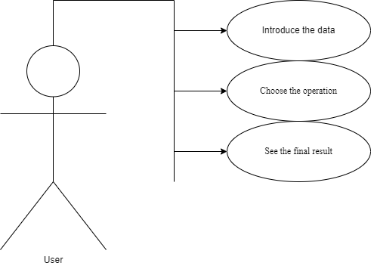
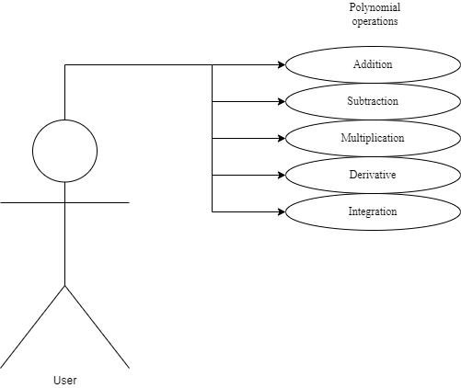

The diagrams above illustrate the user that interacts with the graphical interface of the application. The use-cases represent the actions that he/she can perform:
- The user can choose the data: introducing the two polynomials and the operation that they want to perform
Example of a polynomial: +3x^3-3x^2-1x^1
- The following operations are available on this application:
Addition: the sum of the polynomials (p1+p2) is obtained by adding together the coefficients sharing the same powers of variables
Example: p1: +4x^5-3x^3
p2: -3x^4-5x^3
result: -8x^3 -3x^4 +4x^5
Subtraction: the difference between the polynomials (p1-p2) is obtained by subtracting the coefficients sharing the same powers of variables
Example: p1: -3x^2+2x^1
p2: +5x^2-2x^1
result: +4x^1 -8x^2
Multiplication: the multiplication of each monomial from the first polynomial to each monomial from the second polynomial (p1*p2)
Example: p1: 3x^2
p2: 2x^2+3x^1
result: +9x^3 +6x^4
Differentiation: the derivative of a polynomial has the following formula, applied to each monomial → (x^n)’ = n*x^(n-1)
Example: p1: -4x^3+2x^1
result: +2x^0 -12x^2
Integration: the integral of a polynomial has the following formula, applied to each monomial → ∫x^n = [x^(n+1)]/(n+1)
Example: p1: 3x^3
result: +3/4 x^4 +C
- The user can see the result displayed on the graphical interface. Also, the application has a test function that uses Junit, in order to confirm that the operations are correct.

Planning and Design

UML Diagrams

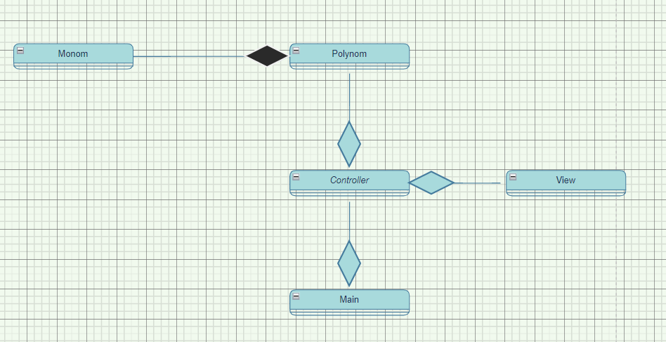

The class diagrams are used in designing and modelling the software. The diagrams describe the classes and their relationships. They enable us to model software in a high level of abstraction and without having to look at the source code. The classes are described by including the attributes, objects and the methods from a specific class. On top we have the name of the class and below it the attributes. A minus in front of the attribute means that the attribute is private. The constructors, getters, setters and methods are listed below the attributes.
What are the benefits of UML diagrams? They are very flexible and easy to draw, and in this way, you can communicate the software architecture effectively.
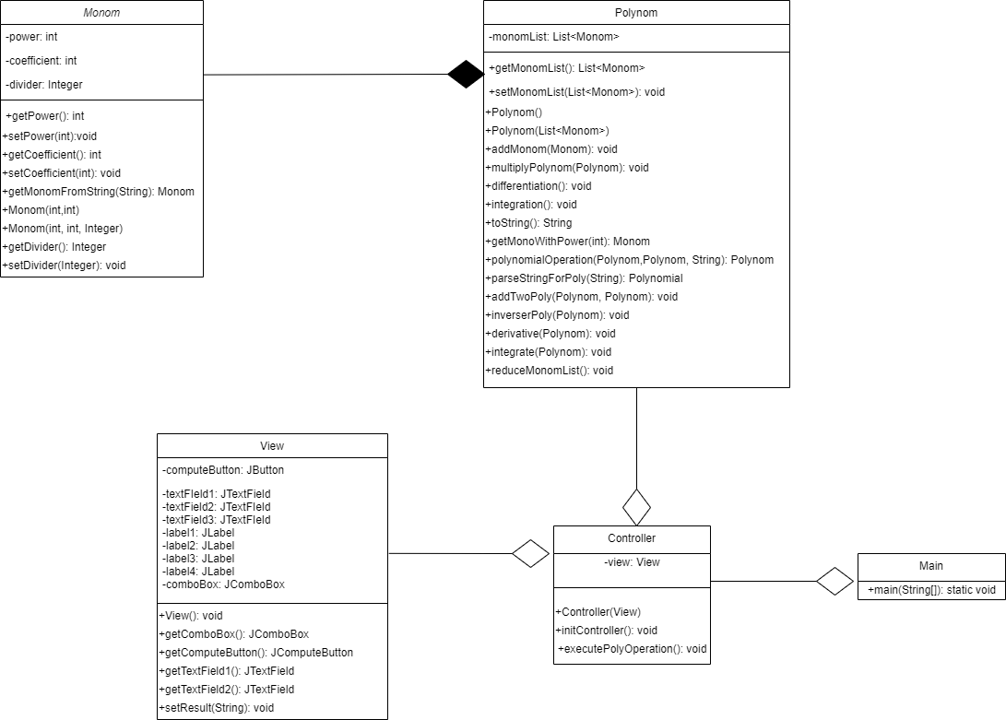

Data structures: The data structures used in this project are mostly primitive types, especially integers and strings, but also complex types such as ArrayList type objects or Lists.
The integers are used for declaring the powers and coefficients of the monomials. The lists were used for storing new created objects such as Monom or Polynom type of objects. ArrayLists are more efficient regarding the memory management, performance and provide a faster access to their content than regular arrays.

Packages: A package in Java is used to group related classes. They are used in order to avoid name conflicts and to write a better maintainable code. The project is organized in 4 packages: com.polynomial, model, view and controller. In an object-oriented development, model-view-controller (MVC) is the name of a methodology or design pattern for successfully and efficiently relating the user interface to underlying data models.
Model: it represents the business layer of application; it carries the data that can also contain the logic to update controller if data is changed. The model package contains the classes Polynom, Monom and PolynomTest, where all the operations take place.
View: it represents the presentation layer of application. It is used to visualize the data that the model contains. The view package contains the View class, where the components that form together the interface are described and declared.
Controller: It works on both the model and view. It is used to manage the flow of application, i.e., data flow in the model object and to update the view whenever data is changed. The controller package contains only the Controller class, which makes the connection between the interface and the user, by using action listeners.
The last package is com.ploynomial, which contains a single class that has the customary main() method.

Implementation
Graphical Interface

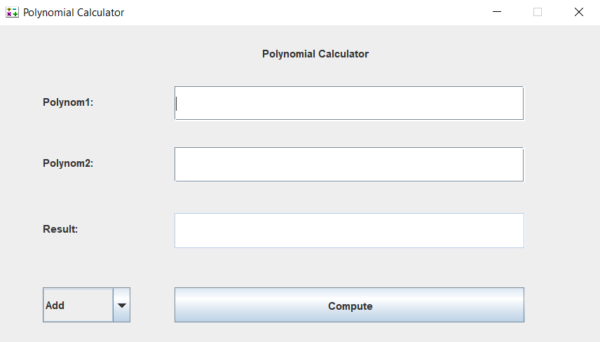

The graphical interface is mostly described in the class View, package view.
It extends the JFrame class, which represents a top-level container that renders a window on the screen and it has the following attributes:
→4 labels - the first one is calling the first polynomial, the second one is calling the second polynomial, the third one represents the result and the last one is the title for the polynomial calculator
→3 text fields - in two of them the user is supposed to introduce the data (the polynomials) but the last one is disabled, so the user cannot write anything there, just see the result
→1 combo box - there the user can choose from all the operations only the one that he/she wants to perform
→1 button - called “Compute”, so when the user clicks on it the result will appear in the corresponding text field
The interface also has a new logo displayed, showing some operations, instead of the classic Java one.

The Controller class, inside the controller package has the method initController() which has the purpose to initialize the controller, so it contains an action listener. The action listener acts whener the user presses the button Compute and then it has to perform the method executePolyOperation().
As the methods says, it executes all the operations, one at a time: we enter the two polynomials as Strings and we collet the data by usint .getText(). We also identify the selected operation in this method. Finally, we get the result and we display it. We have an exception, in case the polynomial was not correct, meaning that the user didn’t introduce it correctly. In this case we display a message “Invalid input.”.

All the operations happen in the package model, in the Polynom and Monom classes.
Monom Class:
It contains the following attributes:
→coefficient (int)
→power (int)
→divider (Integer): this is used for the integration because we will encounter a fraction
It contains getters, setters and two constructors, differentiated by the number of parameters.
It has the following methods:
→getMonomFromString(String): this is a method that splits the polynomial into monomials. It receives a String, and by using .matches() and regular expressions, it determines the form of a monomial: minus/plus(or nothing for the first term if it has a plus) + a digit from 0 to 9 + x + ^ + a digit from 0 to 9 (but can take also negative powers if needed); after identifying this structure it takes the coefficient and power and converts them into integers, by using parseInt(). The method returns a monomial with coefficient and power.

Polynom Class:
It contains the following attributes:
→a list of monomials called monomList (Monom)
It has getters, setters and constructors.
It implements the following methods:
→addMonom(Monom): this function gets as a parameter a monomial and will add it to the list of already added monomials. When it finds that a monomial has the same power as another one, it adds the coefficients from the two monomials and form only one monomial with the same power. We will add the monomial to the final list called result. Finally, we use .sort() so we can order the monomials in ascending powers.
→multiplyPolynom(Polynom): this function takes all the monomials from the second polynomial and multiplies them with each monomial of the first polynomial. It updates the powers and coefficients and adds the monomials to a new list called result. Finally, it sorts the final polynomial. It also contains a method that reduces the monomials with the same power.
→differentiation(): it gets each monomial from only one polynomial and updates the powers and the coefficients in order to perform the derivative correctly. Finally, it sorts the result.
→integration(): it gets each monomial from only one polynomial and updates the power and the coefficient in order to perform the integral correctly. We use the attribute divider from the class Monom, as for the integral we will have a numerator and a denominator as a coefficient. Finally, we sort the final list.
→toString(): we override the method toString(), in order to display the final polynomial
→getMonoWithPower(int): this is a function that verifies if we can find the same power of a specific monomial in a list with other monomials. We used it when we needed to find the monomials with the same power for the addition.
→polynomialOperation(Polynom, Polynom, String): is a method that executes each operation, depending on the choice of the user
→parseStringForPoly(String): this is a function which constructs our polynomial; we have split the monomials by a spacebar. By using the function from the Monom class, we will return a a polynomial, by adding the corresponding monomials.
→inversePoly(Polynom): is a function that puts a minus before each monomial, so that it will help us when we perform the subtraction.
→reduceMonomList(): a method that adds two monomials from the same polynomial, with the same power, by adding their coefficients. It is used in the multiplication operation because we can encounter monomials with the same power.

The Main class has only one method, main, where we instantiate the view and initialize the controller, so that the user can play with the application.

Results
For making sure that the application works correctly, JUnit testing was used. In another class called PolynomTest, the method Test was implemented. There, 2 polynomials were instantiated and operations between them were performed. By using assertTrue it was sure that the test went correcty and that the calculator works.
Here are the operations that were made:
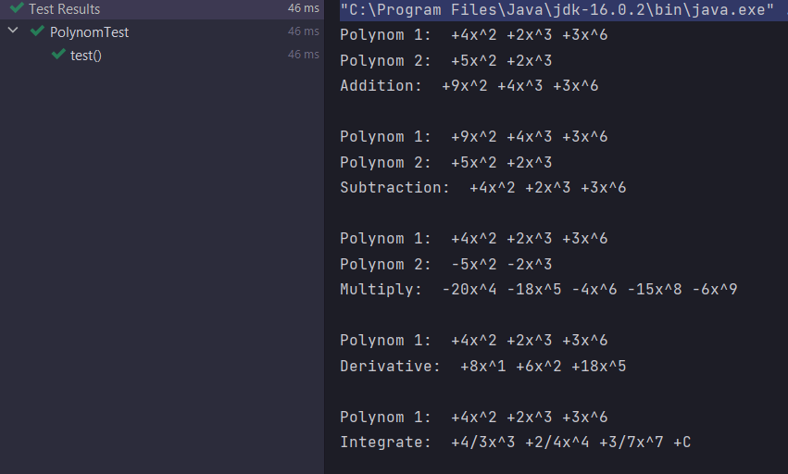

Conclusion
This project was a good exercise for remembering OOP concepts and for improving the skills that I learned in the first semester of this year.I found it very challenging.
In the future, I would like to be more organized as I found out that having a good image of the project before starting to implement and write code and having the problem already organized in my mind and on paper helps a lot. It reduces time and work, and everything seems more clear and easier to work with. I also came to the conclusion that facing problems with your code and trying to solve them by yourself will obligate you to do a lot of research and you can learn better from it. After ending this project, I learnt better how to design an interface with buttons, combobox and text fields, as last semester I designed a game, so my work depended more on the code rather than the interface itself. So, this assignment gave me a chance to learn new things about the graphical interface. For the future improvements of this application, I would like to try implementing the division operation.

Bibliography

- Object Oriented Programming – lectures of prof. Marius Joldos
- Programming Techniques – lectures of prof. Cristina Bianca Pop
- www.stackoverflow.com
- Bro Code – YouTube channel

